ESG SHOWCASE

Modernize Order Processing with DataXstream OMS+ and SAP
Date: January 2022 Author: Mike Leone, Senior Analyst
ABSTRACT: As wholesalers and specialty retailers continue to evolve in the way they satisfy customer requirements, they are constantly pushed to be more agile, efficient, and accurate throughout the entire order lifecycle. They are looking to invest in platforms that can improve efficiency, reduce risk, and ensure that their customers’ experience leads to more business.

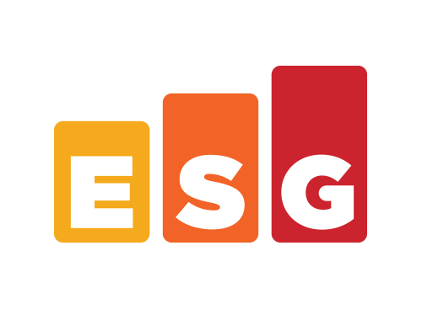
Introduction
Enterprise Strategy Group | Getting to the bigger truth.™

As wholesalers progress down the digital transformation path, their business objectives are constantly evolving. Organizations are rewarded based on the efficiency and agility with which they can effectively respond to customer requests and orders. But several barriers exist in legacy order management operating models. Disjointed tools with bolted-on features lack seamless integration and visibility into product availability and inventory. Manual processes for navigating between tools cause delays and potentially deal-breaking errors. And ongoing operational silos prove costly for organizations looking to effectively scale their businesses. How can organizations expect to satisfy customer requirements when the underlying solutions are not built to effectively integrate or scale at the speed the business? Simply put, they can’t. With DataXstream OMS+, organizations can modernize their approach to sales and order fulfillment through a unified platform that automates business and SAP-managed order processing and increases visibility, efficiency, and agility throughout the order lifecycle.

Challenges of Legacy Order Management
Wholesalers, manufacturers, and distributors are facing challenges to delivering an effective omnichannel experience. Traditional order management processes are fragmented, with several points of order capture and disjointed fulfillment systems leading to delays. When organizations receive multiple orders through multiple channels, the fragmentation makes it impossible to accurately manage orders and properly set customer expectations. Standalone order management systems that require manual entry make it nearly impossible to handle multichannel sales orders and introduce the significant risk of incorrectly entering orders into the system. This is especially true for bulk orders that require updates across internal systems and widely deployed marketplaces, never mind the challenges of accurately creating invoices, printing labels, and arranging shipping. When it comes to product stock, a lack of data visibility across locations can either lead to incorrect “out of stock” notifications or excessive stock in the wrong locations. The last thing an organization wants is to experience stock waste or delays in order fulfillment that lead to unhappy customers, making it clear that organizations need help to deliver the right omnichannel experience that can satisfy strict customer demands while properly setting customer expectations.

Requirements for Modernizing Order Management
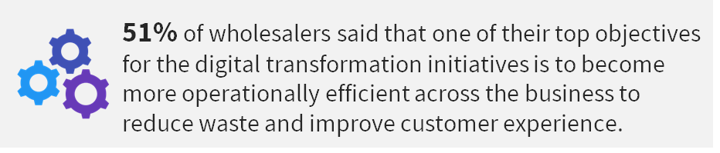
As wholesalers and specialty retailers modernize their operating models to improve data visibility, operational efficiency, and business agility, retail technology spending overall is on the rise. In fact, ESG research shows that 70% of wholesalers are increasing their technology spending over the next year. They are looking to enhance customer engagement, create more agile and efficient operations, and automate workflows with a goal of delivering the best omnichannel experience. When it comes to the objectives for their digital transformation initiatives, 51% of wholesalers are focused on becoming more operationally efficient across the business to reduce waste and improve the customer experience. They are achieving this through initiatives like automating business processes, relying more on real-time data, and improving asset tracking via comprehensive visibility throughout the entire supply chain. By prioritizing agility through increased data visibility and intelligent automation, wholesalers are better able to assess localized demand patterns, identify issues with best response suggestions, and engage in continuous intelligent planning. And by unifying applications and operations, they can reinvent themselves through streamlined back-office processes that can predictably scale based on product availability and customer demand.

Enabling Speed, Agility, and Cost Savings with DataXstream OMS+
DataXstream OMS+ is a software sales solution that delivers a unified interface for SAP order management. Through optimized in-store counter, mobile, and call center sales, OMS+ automates end-to-end business processes, increases data visibility, improves business agility, and transforms operations, resulting in increased revenue, reduced cost, and saved time. End-users are empowered to quickly respond to customer inquiries or questions with an intuitive software layer that sits on top of SAP to enable efficient sales and secure transactions at scale from anywhere.
Retailers can deploy OMS+ directly in the SAP Cloud Platform to manage SAP order processes, quickly find customers and items, understand available inventory, and effectively manage customer expectations. The cloud software solution integrates directly with any pre-existing, on-premises SAP ERP deployments, eliminating the need for any manual software integration. OMS+ uses live SAP data such as product availability and transactions, as well as offline SAP data such as customer information or product descriptions to simplify the sales and fulfillment process. From initial deposit and payment through partial delivery and order changes to the handling of payment changes and final delivery, OMS+ works directly with SAP data to simplify high-touch, multichannel sales transactions. And the result is the continued ability to understand customer requirements, set proper expectations, transact faster, sell more, and improve the overall customer experience, minimizing churn and improving customer loyalty.

Visibility and Agility
Run on traditional terminals, tablets, and smartphones, OMS+ provides organizations with a single interface that enables associates to find the right items faster, see inventory levels in real time across all locations, and track and follow opportunities. Users can automatically transfer or reallocate inventory based on customer requirements, search products and orders, and view customer history, including all product attributes, identification numbers, and descriptions—all directly through the terminal.

Automation
Understanding that automation can greatly reduce the time to create a quote or an order while increasing the accuracy of the order, DataXstream has introduced OMS+ia. OMS+ia enables retailers to automate repetitive manual processes using innovative technology that leverages SAP Data Intelligence. Customer search, material search, inventory sourcing, order creation, quote creation, and product recommendations can all utilize OMS+ia to shorten the time to respond to RFQs and process orders in a faster and more reliable way. By automating repetitive manual tasks, retailers will not only reduce data entry errors, but gain valuable time back to spend on interacting with and serving customers and strategizing on the next deal.

Cost Savings and ROI
By delivering a single order fulfillment platform for the entire organization, OMS+ can significantly reduce an organization’s infrastructure and data footprint. Retailers can avoid costly integrations and maintenance that introduce delays in several areas, whether related to accessing the right data at the right time, quickly completing end-of-day reconciliation, and/or improving inventory management. For retailers, this equates to lower change management costs, reduced inventory storage costs, reduced end-of-day closing times, and fewer order mistakes. By increasing order input speed and improving accuracy, OMS+ reduces order rework and therefore saves valuable money and time.

The Bigger Truth
For many wholesalers, manufacturers, distributors, and specialty retailers, the need to modernize has never been more apparent. Fulfillment requirements are becoming more challenging and more complex by the day due to rising e-commerce, multichannel and cross-channel demands. Organizations are all but forced to modernize their sales management solutions to improve visibility across locations, ensure seamless integrations between software systems, and effectively deliver an ideal customer experience.
With a goal of transforming the way companies handle SAP order management, DataXstream has introduced OMS+, a unified, cross-channel order management solution. With OMS+, the sales and fulfillment lifecycles are transformed to be more agile, efficient, and reliable, leading to improved sales and visibility, while reducing costs and increasing revenue. And the result is a better customer experience, rooted in accuracy, transparency, and continued customer loyalty.

Enterprise Strategy Group is an IT analyst, research, validation, and strategy firm that provides market intelligence and actionable insight to the global IT community.

www.esg-global.com
contact@esg-global.com
508.482.0188
All trademark names are property of their respective companies. Information contained in this publication has been obtained by sources The Enterprise Strategy Group (ESG) considers to be reliable but is not warranted by ESG. This publication may contain opinions of ESG, which are subject to change. This publication is copyrighted by The Enterprise Strategy Group, Inc. Any reproduction or redistribution of this publication, in whole or in part, whether in hard-copy format, electronically, or otherwise to persons not authorized to receive it, without the express consent of The Enterprise Strategy Group, Inc., is in violation of U.S. copyright law and will be subject to an action for civil damages and, if applicable, criminal prosecution. Should you have any questions, please contact ESG Client Relations at 508.482.0188.

ESG Complete Survey Results: 2022 Technology Spending Intentions, Nov 2021. All ESG research references in this white paper have been taken from this complete survey results set.

